EMEIA CLOUD DATA ANALYTICS CAPSTONE PROJECT

Title: Boosting Food Security: Analysing How SME Income Levels and Government Support Drive Agricultural Productivity in the Pursuit of Reducing the Gap to UN Sustainable Development Goal, Zero Hunger.

GROUP MEMBERS:
- Collins Kinzi
- Foster Mesreh
- Tonde Salif
- Irene Mwelu

ABSTRACT
Research Question
Can we close or reduce the gap to Zero Hunger by leveraging agricultural productivity, with a special focus on how SMEs can play a role with the help of government initiatives and increased income levels?
Dataset
This analysis leverages two primary datasets sourced directly from the Food and Agriculture Organization (FAO). The first dataset details agricultural productivity and average incomes at the SME level across some East, West, and Northern African countries. The second provides national-level Agricultural Orientation Index (AOI) values for the same country group. This regional sample forms the core evidence for our investigation.

Findings
We found a strong correlation between income and agricultural productivity, where an increase in income for SMEs resulted in a significant increase in productivity. We noticed little impact from government support, based on the AOI data we had, but this was indicated by how low priority this support is to the agricultural sector. Gender income gaps were also noted in all countries considered for the project; no country has attained equality yet, but some are closer than others, which could be used to benchmark and reduce the gaps in those highly unequal.
Conclusions
Our analysis and research found that although gender income inequality may be a factor to consider, a general focus on empowering SMEs would see some of the income disparities reduced, and therefore an improvement in agricultural productivity. We then looked at the impact of introducing programs that facilitate income increase, like having better price support mechanisms, financial inclusion programs, and improved market access, which showed that they significantly improve agricultural productivity. We also found that prioritizing government support and having better plans for targeting and implementing these programs, focusing on quality support rather than quantity of government spending, and auditing current agricultural programs, will improve the efficiency of agricultural performance by highlighting the best support practices. The greatest impact was seen from having a combined approach of income and government support programs to yield optimum productivity. This increase in productivity would then boost food security and further reduce the gap to zero hunger.

Chapter 1: Introduction

According to the joint annual report published by The Institute for International Law of Peace and Armed Conflict (IFHV), Concern Worldwide, and Welthungerhilfe, decades of progress toward SDG 2: Zero Hunger are evidenced by a significant decline in the Global Hunger Index (GHI) since 2000. However, current data reveals a critical shortfall, with a global GHI score of 18.3 still at a moderate level; the current trajectory is insufficient to reach the low hunger threshold by the 2030 deadline. Despite challenges that remain, there are some promising countries such as Nepal, Mozambique, Togo, Bangladesh, and Somalia.

  - Background: The Central Role of SME Food Producers in GHI reduction

Imagine a local family farm harvesting its maize, a small-scale processor turning fruit into jam for sale, and a cooperative storing grain for a stable supply. These are the faces of the small and medium-sized enterprises (SMEs) that are the backbone of food systems across the developing world. They are not just businesses; they are the largest source of nourishment and livelihood for millions, and they represent the most tangible face of our efforts towards achieving lower hunger levels.

For these millions of food producers, the equation is often straightforward: higher and more regular incomes directly enable the investments that lead to greater productivity. With more income, a farmer can purchase more productive seeds, a processor can buy more production machinery, and a distributor can invest in cold storage to reduce waste. This self-reinforcing cycle of investment to income to greater output is the dynamic that could drive food security expansion. But this engine is not moving as it should be. Widespread income stagnation and disparity among food-producing small and medium-sized enterprises constitute a common barrier to their achieving their potential.

Governments are mindful of this challenge and attempt to correct it through support schemes. Varying levels of government support, as measured by the Agriculture Orientation Index (AOI), the ratio of government agricultural expenditures to agricultural GDP, can help mitigate these disparities (Benin, 2024). The story is not just one of “how much is spent” but “how it is spent”. The key question for policymakers is, what form of support works best to lead to higher incomes and, in turn, higher productivity for the diverse range of SMEs that put food on our tables?

1.2 Problem Statement: Breaking the Low-Income, Low-Productivity Cycle

The core problem that this research addresses is the vicious cycle through which low incomes in agricultural-producing SMEs prevent investment in order to increase productivity, resulting in low incomes. This cycle poses a big and important obstacle to agricultural production in closing the gap to the Zero Hunger goal.

The problem manifests differently across the spectrum of SMEs. Small enterprises, which are typically family enterprises or single-person enterprises, are highly vulnerable to income shocks and typically lack the funds to climb the productivity ladder. Large-sized firms have a little more but tend to hit the ceiling for expansion and cannot access the credit or technology to grow their operations and enter larger markets. Within each group, income differentials, such as those associated with the gender of the head operator, also burden the system with its potential, as much as its workforce is purposefully under-funded.

Government subsidies are intended to break this cycle, but their effects are usually wildly unpredictable. According to Lipton (1980), in certain regions, the available assistance may serve to mitigate income gaps and improve productivity, whereas in other areas, it may prove inadequate. Simply increasing the AOI without understanding its composition and targeting is not an effective strategy. This study will look into this complex interaction, focusing on how disparities in income, within enterprise size and other determinants, are constraining productivity, and how differentiated support by the government can be the greatest driver for change.

1.3 Study Objective: Tracing the Path towards Higher Incomes and Increased Output

The main aim of this study is to establish the most effective ways by which governments can enhance the productivity of food-producing SMEs to surpass the income constraints holding them back. The ultimate goal is to provide an evidence-informed policy guidebook for accelerating Zero Hunger progress. This aim will be achieved through the following precise objectives:

- To quantify the productivity gaps between different classes of agricultural SMEs, that is, the small-scale and large-scale enterprises, and analyse how differences in income result in such a difference.

- To evaluate the effectiveness of government intervention by analysing how a country's Agriculture Orientation Index (AOI) correlates with the average income and productivity of its agriculture-producing SMEs. (DONE IN ANALYSIS)

- To provide actionable insight into the type of government intervention (e.g., direct subsidies, access to credit, training programs, investment in infrastructure) that has the strongest link with closing income and productivity disparities, particularly for the lowest income small-scale farmers.

1.4 Justification for the Study: Towards Smarter, More Effective Policy

This research will try to move beyond generic calls for "more investment" in agriculture. Drawing on cross-country evidence to rank what works, this study could help governments and development agencies design smarter, better-targeted policies. For the woman who cannot generate enough on her land and the farmer with the medium-sized farm that cannot break into new markets, smart policy can transform their lives. Research indicates that closing gaps in resources, caused by income disparities, has the potential to increase farm yields by 10% to 25% (Huyer, 2016), directly increasing food supplies and rural incomes (Puskur et al., 2023).

This study will address the very essence of SDG Target 2.3, whose aim is to double the incomes and productivity of small-scale food producers. It accomplishes this by providing a realistic evaluation of the levers, that is, government support and revenue, through which that vision can be achieved.

1.5 Study Scope and Delimitations

This study will follow a quantitative, cross-national comparison of agricultural SMEs in several developing nations. Comparisons will be based on data along two primary structural variables: firm size (Small vs. Large) and government support (as reflected in the national AOI).

One of the principal constraints is the availability of granular, uniform data for each country.
While income disparities by gender will be noted, the central comparative view will be that of the size of the SME. From this view, one can clearly see how structural differences influence income and productivity, and how government policy can be shaped to address the particular needs of small-scale compared to large-scale food producers.

1.6 Methodology Overview

This research will be conducted based on secondary data from FAO using quantitative methods. This data contains information on 12 African countries with a focus on the average income and producer productivity per SME size, and based on Gender as well. We have a dataset that has AOI data for the 12 countries to show government support for the respective agricultural sectors. Our analysis will consist of three phases:

- Regression Analysis: To estimate the income-SME size-national AOI-productivity outcome relationships.

- Descriptive Analysis: To build the income and productivity landscape by SME size and national context.

- Comparative Policy Analysis: To identify which countries have good AOI scores and superior SME performance, and to look at specific kinds of interventions (e.g., focusing on financial inclusion, infrastructure, or extension services) that correlate with success. This will provide tangible instances of effective government intervention.

Chapter 2: Literature Review & Theoretical Framework

Agricultural productivity is a key factor in economic development and food security in sub-Saharan Africa. However, numerous challenges still hamper production: rapid population growth, climate change, land degradation, low adoption of modern technologies, insufficient infrastructure, and limited access to markets. In this context, it is urgent to identify effective strategies to increase agricultural productivity, meet growing food demand, and contribute to sustainable development.
This chapter presents the theoretical foundations of the agricultural productivity cycle. It then draws on empirical data on income, SME size, and productivity, before analyzing the role of government discourses and policies. Finally, it examines the gender dimensions of agricultural income and productivity and identifies research gaps.

2.1 Theoretical Foundations of the Agricultural Productivity Cycle
Agricultural productivity is defined as the amount of produce produced per unit of cultivated land or per agricultural worker. It is usually measured by crop yield (tonnes/hectare) or output per worker. Factors influencing this productivity include:
• inputs (seeds, fertilizers, pesticides),
• water availability and irrigation techniques,
• the level of mechanization and digitalization,
• capital and labour,
• access to markets.
The literature highlights that improving agricultural productivity is a key lever for combating hunger and reducing poverty. According to the FAO (2015), it is a key indicator of the sustainability and competitiveness of the agricultural sector. Empirical studies (Nagarajan et al., 2018) show that investment in irrigation, water management, training, and technological innovation contributes to significantly improving yields.
Furthermore, agricultural SMEs play a central role in this cycle. They are heterogeneous (size, sector, location), but their income largely determines their ability to invest in modern technologies and increase their production. According to the FAO (2018), increasing food production by these SMEs is one of the most effective ways to reduce hunger and malnutrition.
Finally, food security, as defined by the FAO, is achieved when everyone has access to sufficient, safe, nutritious, and sustainable food. It is based on four dimensions: availability, accessibility, utilization, and stability. Increasing the agricultural productivity of SMEs is therefore a necessary step to strengthen this food security.

2.2 Empirical Evidence on Income, Productivity, and SME Size
Empirical research shows that reducing resource gaps between agricultural SMEs can improve yields by 10 to 25%. However, small SMEs remain vulnerable and depend on external support (credit, training, subsidies).

2.2.1 Income and productivity
Statistical analysis reveals a weak and insignificant correlation between the average income of small SMEs and their productivity (r ≈ 0.17; p ≈ 0.33). In other words, higher income does not systematically imply higher productivity, probably due to other structural constraints (lack of infrastructure, high cost of inputs).

2.2.2 Government support
In contrast, the agricultural support index (AOI) is significantly correlated with productivity (r ≈ 0.35; p ≈ 0.036). An increase of 0.1 points in the AOI leads on average to an increase of 2.9 points in productivity. This confirms that the role of the State and agricultural policies is decisive.

2.2.3 Country-specific effects
The data reveal strong heterogeneity across countries. ANOVA shows significant differences in productivity (p < 0.001). For example, in Mali, the correlation between income and productivity is weaker than in other countries (Senegal, Togo), highlighting the importance of national and institutional contexts.
Other studies complement these findings. Resnick and Birner (2019) show that sustained public investment sustainably improves productivity and reduces poverty. Holden et al. (2018) highlight that limited access to finance and markets remains one of the main constraints in sub-Saharan Africa.

2.3 Government Discourse: The “How” vs “How Much”
Empirical results confirm that it is not only the level of public spending that matters, but also its quality and direction. A high but poorly targeted agricultural budget can be ineffective. Conversely, strategic investments (rural infrastructure, agricultural extension, accessible credit) generate measurable productivity gains.
Thus, the debate is between "how much" (volume of expenditure) and "how" (effectiveness of allocations). Experience shows that the most effective public policies are those that combine financing, technical support and access to markets.

2.4 Gendered Dimensions of Agricultural Income and Productivity

Gender plays a major role in agricultural dynamics. In many African countries, women represent nearly 50% of the agricultural workforce, but they have fewer resources than men (land, credit, inputs, training).
According to the FAO (2011), this access gap results in a productivity loss of 20 to 30%. However, experiences in Rwanda, Malawi and Niger show that when women benefit from the same resources as men, their yields are equivalent, or even higher.
Statistical analyses also confirm the existence of significant income gaps between men and women, especially in small SMEs. However, these differences do not necessarily translate into productivity gaps, suggesting that inequalities are more structural and sociocultural than technical.

2.5 Synthesis and Identification of Research Gap
From the literature review and empirical data, three major findings emerge:
1. Income and size of SMEs directly influence agricultural productivity.
2. Government support is essential, but its quality takes precedence over quantity.
3. Gender inequalities reduce the overall potential for agricultural productivity and therefore food security.
However, several gaps remain:
• Few studies simultaneously cross-reference SME size, revenues, productivity and effectiveness of public support.
• The combined role of public and private funding remains insufficiently documented.
• The integration of the gender dimension into agricultural economic analyses remains too limited.
These gaps fully justify the present research, which aims to empirically link SME income, government support and agricultural productivity, while integrating the perspective of food security and the Sustainable Development Goals.

Chapter 3: Research & Analysis

3.1 Regression Analysis

To have an overview of factors that affect agricultural productivity based on our datasets, we did a regression analysis that showed us that income had a significant positive effect (Avg_income_SMEs: 0.0025 (p=0.005)). This means that with every $1 increase, productivity increases by 0.0025 units. We also noticed that AOI’s effect on productivity was insignificant (AOI: 0.0588 (p=0.906)), which could point to inefficient policy implementation or a time lag in impact evidence. Gender effect (C(Gender)[T.Female]: 1.0979 (p=0.466) and [T.Male]: -0.3837 (p=0.781)) also shows insignificant impact which could mean that the overall productivity problem is not based on inequality but in the general ineffectiveness of systems that support SMEs.
The outcome of this analysis led us to consider how income increases can be leveraged to increase agricultural productivity.

3.2 Descriptive Overview of the SME Landscape

Small and medium-sized enterprises are the backbone of African economies, contributing significantly to more than 50% of GDP in most African countries, providing 80% of the total employment, and reducing poverty. Despite this, African SMEs face challenges like limited access to finances, regulatory complexities, and constrained market access. This prevents growth and sustainability toward zero hunger in Africa. To address these issues, we reviewed data from sample countries in Africa and came up with the following research and analysis:

3.2.1 Income-Productivity Analysis

Our datasets include SDG data, which incorporates SME_size, Countries, producers_productivity, Gender, and Avg_income_SMEs, as well as the Agriculture orientation index (AOI) dataset.
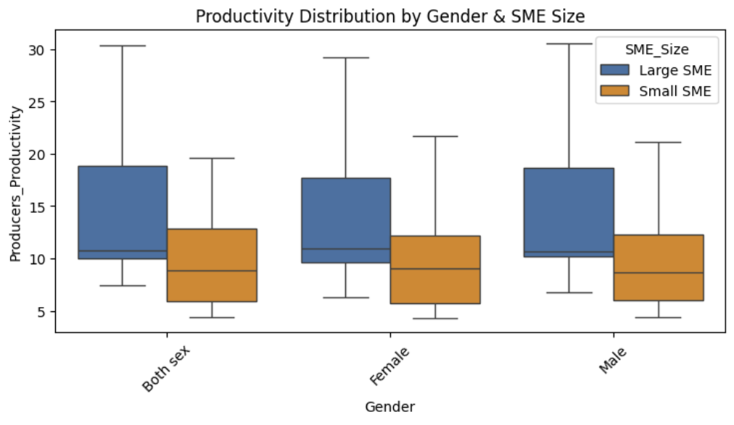
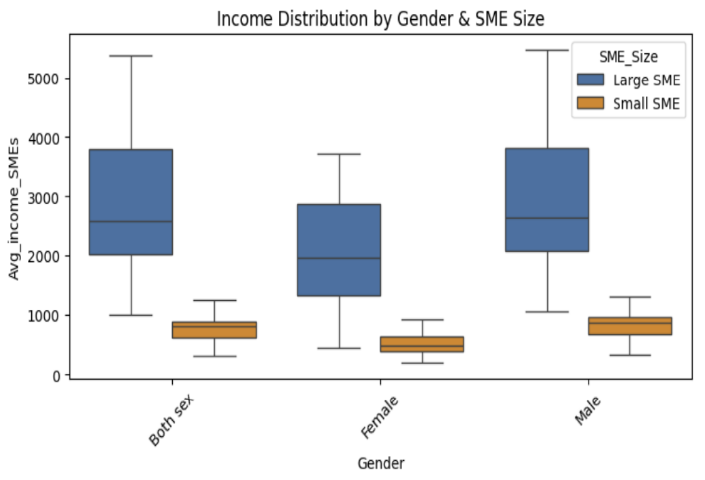
In our research, we did multiple variations of Income-productivity analysis for both Large and small-sized SMEs across different African countries to come up with an idea of income distribution in the different variations, including income V Gender, with results showing a stark contrast in relation to productivity V Gender distributions as especially in the Small SMEs, as shown:
Fig 1: Income V Gender
Fig 2: Productivity V gender
The Graphs show a lower income for females compared to their male counterparts, even though productivity is similar. In our research, we also conducted a Gap Analysis and policy implications for each SME size shown:

3.2.2 Gap Analysis

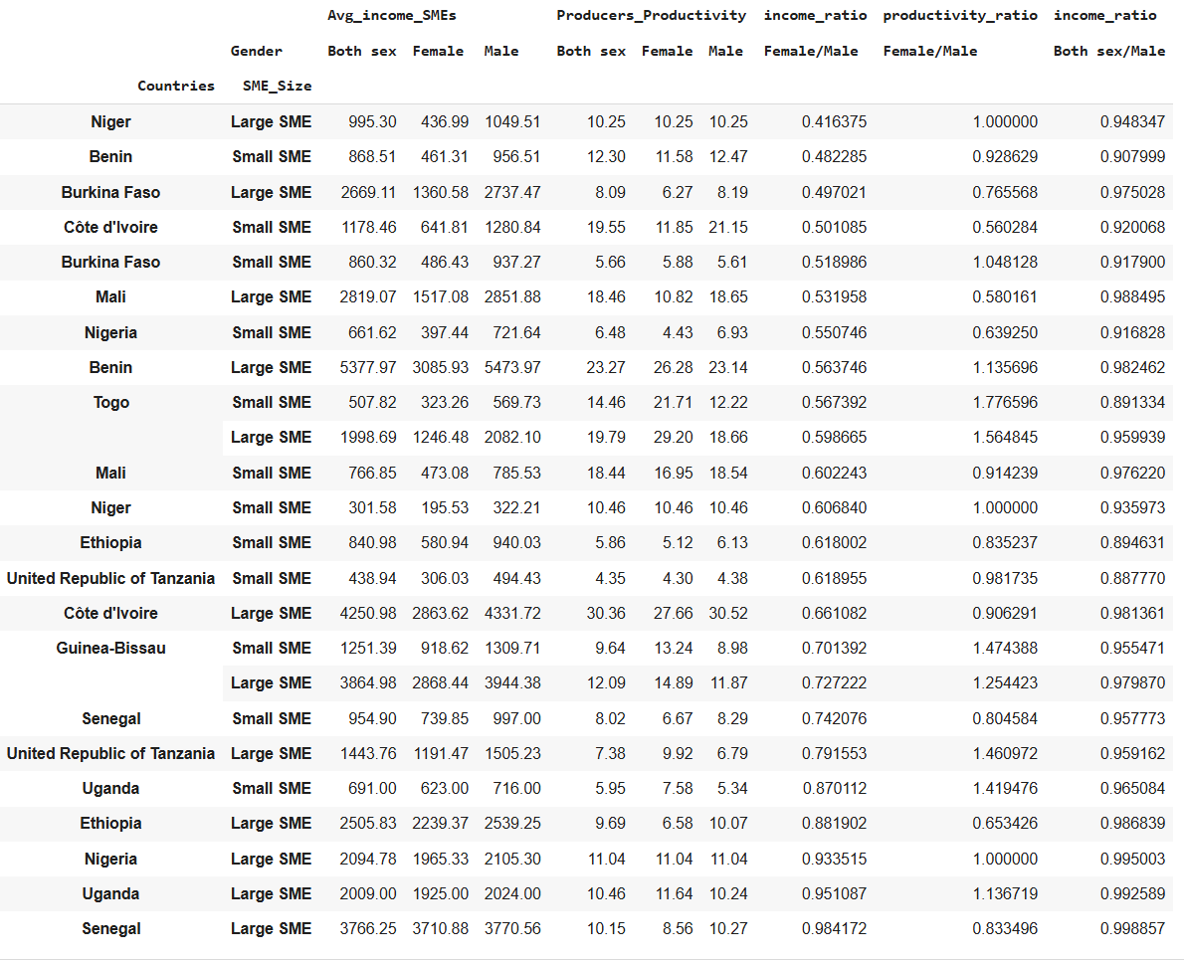

Fig 3: Comprehensive Gap Analysis

The income ratio (Female/Male) column clearly highlights the income gap. Most countries show a ratio less than 1.0, indicating that, on average, women earn less than men. For example, in Benin, for Small SMEs, the income ratio is 0.416, meaning women earn about 42% of what men earn. The productivity ratio (Female/Male) column, however, is more mixed. Some countries show ratios greater than 1.0 (e.g., Burkina Faso, Small SME at 1.048), suggesting that in certain sectors, female workers are more productive than their male counterparts despite earning less.

The data reveals a consistent gender-based income gap across the board, with men earning more than women. However, the analysis of productivity ratios shows that this income gap does not always correlate with productivity. In some cases, women are more productive, yet they still earn less, suggesting that factors beyond productivity are contributing to the wage disparity.
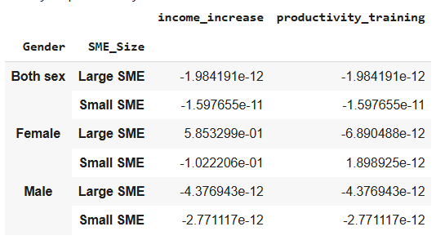
Fig 4: Policy Impact Analysis

The Policy Impact Analysis table simulates the effect of a hypothetical intervention focused on productivity training; the figures show a change in income, both negatively or positively, from the intervention, with negatives being near zero numbers, signifying next to no change in the intervention.
For females in Large SMEs, the intervention shows a significant positive impact on income (5.853299e-01, which is approximately a 58.5% increase). This suggests that productivity training is highly effective at boosting income for women in large businesses. For females in Small SMEs, the intervention has a negative impact on income (-1.022206e-01, which is approximately a -10.2% decrease). This analysis highlights that not all policies are universally beneficial and must be carefully targeted, as impact can vary depending on factors like gender and the size of the business.

3.2.3 AOI Analysis: Government Support Analysis

We reviewed the Government's support for different countries in Africa using the Agricultural Orientation Index (AOI), which is proposed to give an overview of the government's spending oriented towards the agriculture sector. The Ideal scenario is an AOI of 1(marked by the red dashed line), which shows that a government's support is proportional to the agricultural sector size in the economy.
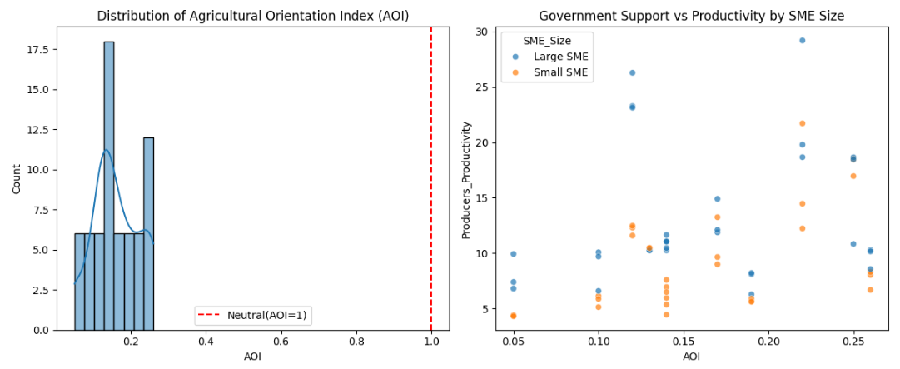
Fig 5: Distribution of AOI and Government Support
From the first Graph, all the data points are clustered between an AOI of approximately 0.05 and 0.3. Since these values are all significantly less than 1, it indicates a strong and consistent government bias against the agricultural sector.

In the second graph, which shows the relationship between the level of government support and the productivity of producers separated by SME size, a positive trend is noticed in the producers_productivity above 20, as they are found where the AOI is above 0.2. This suggests that as government spending becomes less biased against agriculture, there is a greater likelihood of achieving higher productivity.

3.3 Comparative Policy Analysis

3.3.1 Cross-Country Comparative Analysis

We wanted to see the top-performing countries from our datasets based on income disparity vs Average productivity by country, as represented in the figure below:

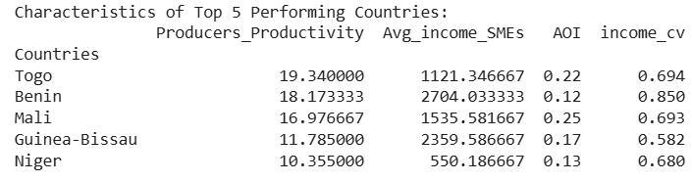
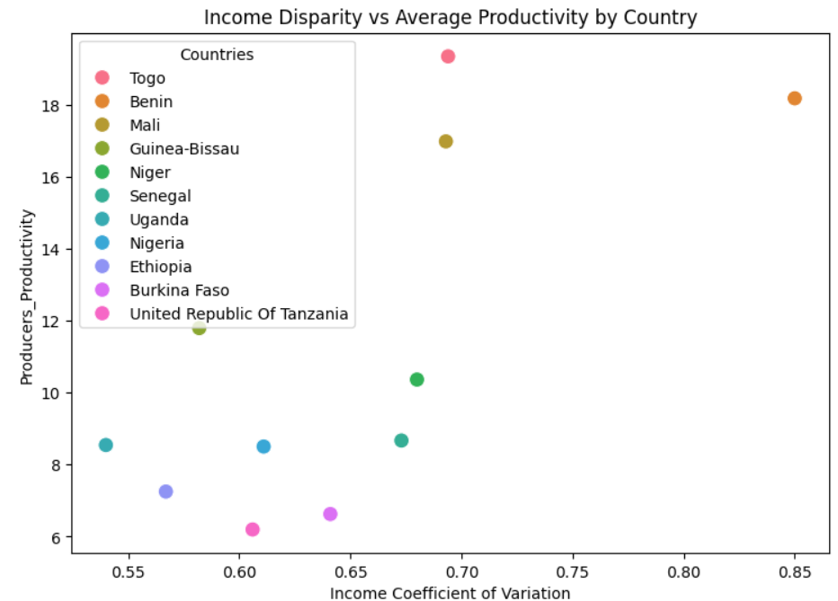

Fig 6: Cross-Country Comparative analysis
We noticed that in the first visualization, Togo, Benin, and Mali had high productivity despite having high inequality, and Burkina Faso and Tanzania had low productivity despite having relatively lower inequality. This challenges the idea that equality drives performance. We notice this from the table as well, where, despite AOI and Avg_income_SMEs not being the highest, Togo still manages to top the list of high productivity.
Based on these comparisons, we did in-depth research on the top two performers, Togo and Benin, and the bottom two, Burkina Faso and Senegal. We needed to understand what Togo does so as to have such high productivity, and if that can be implemented across the region to achieve similar high yields in agriculture.

3.3.2 Case Study of Top and Bottom Performers in terms of Productivity Levels

We found that Togo and Benin stand out as the top performers in agricultural productivity due to strategic government incentives that directly boost farmer income and output. Benin was projected to become the region's leading cotton producer in 2024, a success driven by a broader economic strategy that has relied on the private sector since 2016 to modernize agriculture, which employs 70% of the population and accounts for 35% of GDP (MINISTRY OF SMES AND EMPLOYMENT PROMOTION; Africanews, 2024). Similarly, Togo is uniquely positioned for rapid progress because of its "macroeconomic stability, provided by the CFA franc," which creates a predictable environment for investment. The government and partners are aggressively intervening with programs that provide "subsidized access to high-yield seeds and fertilizers for smallholder farmers," a direct incentive designed to "boost domestic food availability and directly increase incomes" (World Bank, 2022; Abudu, 2023). For both nations, linking support to clear income generation for farmers is a key driver of productivity increase.

In contrast, Burkina Faso and Senegal appear as bottom performers, primarily due to significant gaps in processing and access to financing that limit agricultural value and farmer income. In Senegal, a major challenge is the lack of processing, with only about 5% of fruits and vegetables being processed, leading to post-harvest losses and missed income opportunities despite the high potential of its horticulture sector. Although the government has support systems like the DER and ADEPME, access to credit remains a significant hurdle, with many loan applications rejected. Burkina Faso faces a similar financing gap, where only 15% of farmers benefit from bank credit, severely hindering productivity on farms that are described as "small and low in productivity." While Burkina Faso has recently introduced strong incentives like "total exemption from Value Added Tax (VAT) and customs duties" for SME equipment and is creating a new Agricultural Bank, these measures are very new (2023-2025), suggesting their impact on overall productivity is not yet fully realized (Gaspard BAYALA, 2024). The key gap for these two countries is effectively translating government incentives into increased income for farmers through better access to credit and vital processing infrastructure.

3.3.3 Policy Simulation Impact

Considering all the hindrances to productivity we have seen so far, we decided to simulate some policies like income support, government investment, and a combined policy approach to the agricultural sector to see if we could predict any significant changes to productivity. The graph below shows the possible outcomes of such an approach:

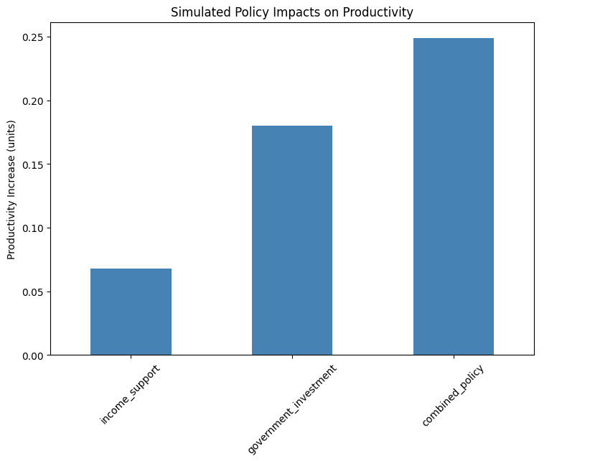
Fig 7: Simulated Policy Impact

For this simulation, we considered three scenarios: a 20% increase in income for the lower income quartile, a 25% increase in government support, and a combined approach where we do both the 20% income increase and the 25% AOI increase. As seen in the graph, as much as income support and government investment saw an increase in productivity (0.068 units, 0.18 units, respectively), a more efficient way would be to do both initiatives to have a better outcome (0.249 units increase), which is higher than when you add both units separately. This creates synergy where policies reinforce each other and multiple constraints are addressed at the same time.

Chapter 4: Discussion, Conclusions & Future Research

4.1 Conclusion
Our evidence conclusively shows that productivity improvements require a combined-policy strategy, merging income enhancement with strategically tailored government support. The strong positive relationship between SME income levels and productivity underscores that farmers must have sufficient capital to invest in quality inputs, technology, and sustainable practices. However, income alone is insufficient without the enabling environment that targeted government interventions provide.

The most impactful insight emerges from the policy simulation we did, revealing that integrated approaches yield substantially greater results than isolated interventions. This synergy effect highlights that effectively implemented targeted support acts as a multiplier, enhancing the productivity returns from every additional dollar of farmer income. Programs that combine direct income support with complementary investments in infrastructure, market access, and knowledge transfer create the foundation for sustainable productivity growth.

The analysis clearly indicates that blanket approaches to agricultural support yield limited results compared to targeted interventions designed around specific value chains and farmer segments. Success depends not merely on the quantity of government expenditure but on its strategic orientation and implementation quality. Policies must recognize that productivity growth emerges from addressing multiple constraints simultaneously through coordinated interventions.

4.2 Limitations of The Study

While this analysis provides valuable insights into productivity drivers, several limitations highlight critical areas where better data coverage could enhance policy targeting. The cross-sectional nature of the data reveals correlations but cannot definitively establish causality between government support and productivity outcomes. This limitation underscores the need for more sophisticated monitoring systems that can track how specific interventions translate into productivity growth over time.

The Agricultural Orientation Index (AOI) metric, though useful for comparative analysis, does not capture the qualitative aspects of government support that often determine program success. This limitation is particularly relevant for understanding why countries with similar expenditure levels achieve markedly different production capacity. The missing dimension of implementation quality, including program efficiency, targeting accuracy, and adaptation to local conditions, represents a crucial gap in current measurement approaches. As the analysis suggests, effectively implemented targeted support likely explains much of the variation in productivity outcomes between countries with comparable AOI values.

Furthermore, the absence of data on contextual factors such as local governance quality, climate resilience measures, and security conditions limits our understanding of the kind of environment necessary for productivity improvements. These unobserved variables may significantly influence how effectively both income increases and government support translate into higher agricultural production.

4.3 Future Research Avenues

Future investigations should prioritize establishing causal pathways that track how specific government interventions translate into productivity increases across different farming contexts. Such research would move beyond correlation to identify which combinations of support yield the highest returns on investment.

There is a crucial need for research examining the implementation mechanisms that distinguish highly effective government programs from less successful ones. Studies should analyze how targeting precision, delivery efficiency, and adaptive management practices influence the productivity outcomes of agricultural support initiatives.

Further research should explore how different factors affect the effectiveness of government support. Investigating how local governance structures, climate adaptation measures, and digital infrastructure influence program outcomes would enable more tailored and effective policy design. Additionally, research on how to best sequence interventions, determining which forms of support should come before others, would provide valuable guidance for phased implementation strategies.

Finally, developing more nuanced metrics that capture not just the quantity but the quality of government support would significantly advance our ability to identify and replicate successful approaches. Such metrics could help policymakers distinguish between merely spending more and spending more effectively to drive productivity growth.

References
- Lipton, M. (1980). Migration from rural areas of poor countries: the impact on rural productivity and income distribution. World development, 8(1), 1-24.

- Benin, S. (2024). Two decades after Maputo, What’s in the CAADP ten percent? Determinants and effects of the composition of government agriculture expenditure in Africa. Intl Food Policy Res Inst.

- Huyer, S. (2016). Closing the gender gap in agriculture. Gender, Technology and Development, 20(2), 105-116.

- Puskur, R., Jumba, H., Reddy, B., Etale, L., Ragasa, C., Mishra, A., ... & Cole, S. (2023). Closing gender gaps in productivity to advance gender equality and women’s empowerment.

- Ivette Keubeng Gniteddem. AGRICULTURAL PRODUCTIVITY IN SUB-SAHARAN AFRICA: EFFECTS ON PRODUCTION AND FOOD PRICE VOLATILITY. Economics and Finance. University of Dschang (Cameroon), 2023. French.8(1), 19-23. https://shs.hal.science/tel-04608489v1/file/M%C3%A9moire_KEUBENG.pdf

- PAN Africa chamber of Commerce and industry. Financing Small and Medium Enterprises (SMEs) in Africa: A Crucial Imperative for Chambers https://www.pacci.org/fr/financing-small-and-medium-enterprises-smes-in-africa-a-crucial-imperative-for-chambers/

- FAO (2021). "Statistiques de la production de cultures". http://www.fao.org/faostat/fr/#data/QC FAO, FIDA, PAM, OMS, UNICEF & OMS (2019).

- Abudu, D. (2023). ‘Agricultural and industrial policies for inclusive growth in Togo’. ODI working paper. London: ODI.

- World Bank. (2022, May 23). Project Appraisal Document on a Proposed Grant in the Amount of SDR 56.9 Million to the Togolese Republic for a Sustainable Agricultural Transformation Project. World Bank Group. Report No: PAD5006.

- MINISTRY OF SMALL AND MEDIUM-SIZED ENTERPRISES AND EMPLOYMENT PROMOTION:https://pmepe.gouv.bj/article/55/politique-nationale-promotion-developpement-petites-moyennes-entreprises[SUMMARY OF THE NATIONAL POLICY DOCUMENT FOR THE PROMOTION AND DEVELOPMENT OF SMALL AND MEDIUM-SIZED ENTERPRISES 2025-2034] Published on: 06/11/2025

- Gaspard BAYALA, Speech by the Minister of 𝐌𝐢𝐧𝐢𝐬𝐭𝐫𝐞 𝐝𝐮 𝐃e𝐯𝐞𝐥𝐨𝐩𝐩𝐞𝐦𝐞𝐧𝐭 𝐈𝐧𝐝𝐮𝐬𝐭𝐫𝐢𝐞𝐥,𝐝𝐮 𝐂𝐨𝐦𝐦𝐞𝐫𝐜𝐞,𝐝𝐞 𝐥'𝐀𝐫𝐭𝐢𝐬𝐚𝐧𝐚𝐭 𝐞𝐭 𝐝𝐞𝐬 𝐏𝐞𝐭𝐢𝐭𝐞𝐬 𝐞𝐭 𝐌𝐨𝐲𝐞𝐧𝐧𝐞𝐬 𝐄𝐧𝐭𝐫𝐞𝐩𝐫𝐢𝐬𝐞𝐬 "I𝐨𝐮𝐫𝐧e𝐞 𝐦𝐨𝐧𝐝𝐢𝐚𝐥𝐞 𝐝𝐞𝐬 𝐦𝐢𝐜𝐫𝐨𝐬,𝐩𝐞𝐭𝐢𝐭𝐞𝐬 𝐞𝐭 𝐦𝐨𝐲𝐞𝐧𝐧𝐞𝐬 𝐞𝐧𝐭𝐫𝐞𝐩𝐫𝐢𝐬𝐞𝐬:𝐥𝐚 𝐝e𝐜𝐥𝐚𝐫𝐚𝐭𝐢𝐨𝐧 𝐝𝐮 𝐌𝐢𝐧𝐢𝐬𝐭𝐫𝐞 𝐝𝐮 𝐃e𝐯𝐞𝐥𝐨𝐩𝐩𝐞𝐦𝐞𝐧𝐭 𝐢𝐧𝐝𝐮𝐬𝐭𝐫𝐢𝐞𝐥,𝐝𝐮 𝐂𝐨𝐦𝐦𝐞𝐫𝐜𝐞,𝐝𝐞 𝐥'𝐀𝐫𝐭𝐢𝐬𝐚𝐧𝐚𝐭 𝐞𝐭 𝐝𝐞𝐬 𝐏𝐞𝐭𝐢𝐭𝐞𝐬 𝐞𝐭 𝐌𝐨𝐲𝐞𝐧𝐧𝐞𝐬 𝐄𝐧𝐭𝐫𝐞𝐩𝐫𝐢𝐬𝐞𝐬. »June 27, 2024

